Test Report

**Project Name: LYON AUTOSIB SERVICE**

**Document Date: <2024.01.19>**

Table of Contents

Testing Scope 4

1.1. Test Environment 4

1.2. Testing Team 4

Test Results 5

1.3. Executed Test Cases 5

1.4. Exploratory testing 5

Defects 6

1.5. New defects 6

1.6. Validated bugs 6

1.7. Old bugs still open 6

Conclusions 7

# Testing Scope

| **Product/Feature** | **Testing Period** | **Tested Builds** | **Deployment Date** |
| --- | --- | --- | --- |
| LYON AUTOSIB - Car repair and maintenance service | 2023.12.03 - 2024.01.03 | 1.0 | 20.01.2024 |
| Main menu bar functionality |  |  |  |
| Home page, About us, Services, Blog, Photo gallery, Contact page, Contact form, Appointments form, Search |  |  |  |

## Test Environment

| **Test Environment** | **Software Details** | **Comments** |
| --- | --- | --- |
| Laptop | ASUS TUF Gaming F15  Win 11 Pro(OS build: 22621.3007)  OS Version: 22H2 |  |
| Google Chrome -Version 120.0.6099.200 (Official Build) (64-bit) |  |
| Mobile Device | Samsung Galaxy A54  Model name: SM-A546B/DS  One UI version 6.0 /  Android version: 14  Chrome Version 120.0.6099.230 |  |

## Testing Team

| **Role** | **Name** | **Comments (e.g. test effort h)** |
| --- | --- | --- |
| Junior tester | Irina Bancila | 90h |
|  |  |  |

# Test Results

## Executed Test Cases

| **Functionality** | **Total** | **Pass** | **Failed** | **Blocked** | **Not Run** | **Defects** |
| --- | --- | --- | --- | --- | --- | --- |
| Main menu bar | 1 | 0 | 1 | 0 | 0 | [0056132](https://bugs.scoalainformala.ro/view.php?id=56132) |
| Home page | 7 | 3 | 4 | 0 | 0 | [0056047](https://bugs.scoalainformala.ro/view.php?id=56047)  [0056038](https://bugs.scoalainformala.ro/view.php?id=56038) [0056031](https://bugs.scoalainformala.ro/view.php?id=56031)  [0056034](https://bugs.scoalainformala.ro/view.php?id=56034) |
| About us | 4 | 2 | 2 | 0 | 0 | [0056063](https://bugs.scoalainformala.ro/view.php?id=56063)  [0056070](https://bugs.scoalainformala.ro/view.php?id=56070) |
| Services | 10 | 8 | 2 | 0 | 0 | [0056093](https://bugs.scoalainformala.ro/view.php?id=56093)  [0056104](https://bugs.scoalainformala.ro/view.php?id=56104) |
| Blog | 10 | 9 | 1 | 0 | 0 | [0056151](https://bugs.scoalainformala.ro/view.php?id=56151) |
| Photo gallery | 4 | 3 | 1 | 0 | 0 | [0056171](https://bugs.scoalainformala.ro/view.php?id=56171) |
| Contact page(Contact form) | 13 | 6 | 7 | 0 | 0 | [0056179](https://bugs.scoalainformala.ro/view.php?id=56179)  [0056204](https://bugs.scoalainformala.ro/view.php?id=56204)  [0056207](https://bugs.scoalainformala.ro/view.php?id=56207)  [0056256](https://bugs.scoalainformala.ro/view.php?id=56256) [0056226](https://bugs.scoalainformala.ro/view.php?id=56226) [0056225](https://bugs.scoalainformala.ro/view.php?id=56225) |
| Appointment form | 12 | 2 | 10 | 0 | 0 | [0056237](https://bugs.scoalainformala.ro/view.php?id=56237)  [0056271](https://bugs.scoalainformala.ro/view.php?id=56271)  [0056255](https://bugs.scoalainformala.ro/view.php?id=56255) |
| Search | 5 | 4 | 1 | 0 | 0 | [0056277](https://bugs.scoalainformala.ro/view.php?id=56277) |
| **Overall Results** | **66** | **37** | **29** | **0** | **0** | **21** |

## Exploratory testing

| **Functionality** | **Defects** |
| --- | --- |
| Home page | [0056047](https://bugs.scoalainformala.ro/view.php?id=56047), [0056038](https://bugs.scoalainformala.ro/view.php?id=56038)[, 0056031](https://bugs.scoalainformala.ro/view.php?id=56031), [0056034](https://bugs.scoalainformala.ro/view.php?id=56034) |
| About us | [0056063](https://bugs.scoalainformala.ro/view.php?id=56063), [0056070](https://bugs.scoalainformala.ro/view.php?id=56070) |
| Services | [0056093](https://bugs.scoalainformala.ro/view.php?id=56093), [0056104](https://bugs.scoalainformala.ro/view.php?id=56104) |
| Blog | [0056151](https://bugs.scoalainformala.ro/view.php?id=56151), [0056170](https://bugs.scoalainformala.ro/view.php?id=56170), [0056163](https://bugs.scoalainformala.ro/view.php?id=56163) |
| Photo gallery | [0056171](https://bugs.scoalainformala.ro/view.php?id=56171) |
| Contact page(Contact form) | [0056179](https://bugs.scoalainformala.ro/view.php?id=56179), [0056204](https://bugs.scoalainformala.ro/view.php?id=56204) , [0056207](https://bugs.scoalainformala.ro/view.php?id=56207), [0056256](https://bugs.scoalainformala.ro/view.php?id=56256)[, 0056226](https://bugs.scoalainformala.ro/view.php?id=56226)[, 0056225](https://bugs.scoalainformala.ro/view.php?id=56225) |
| Appointment form | [0056237](https://bugs.scoalainformala.ro/view.php?id=56237), [0056271](https://bugs.scoalainformala.ro/view.php?id=56271), [0056255](https://bugs.scoalainformala.ro/view.php?id=56255) |
| Search | [0056277](https://bugs.scoalainformala.ro/view.php?id=56277) |

# Defects

## New defects

| **Defect ID** | **Defect summary** | **Severity** |
| --- | --- | --- |
| [0056271](https://bugs.scoalainformala.ro/view.php?id=56271) | Appointment form: valid data - no confirmation message is received. | major |
| [0056256](https://bugs.scoalainformala.ro/view.php?id=56256) | Contact form: invalid email address. | normal |
| [0056255](https://bugs.scoalainformala.ro/view.php?id=56255) | Appointment form: time picker and date picker not working. | major |
| [0056237](https://bugs.scoalainformala.ro/view.php?id=56237) | Appointment Form: Form fields are not marked as required. | major |
| [0056226](https://bugs.scoalainformala.ro/view.php?id=56226) | Contact form: an invalid phone number may be entered. | normal |
| [0056225](https://bugs.scoalainformala.ro/view.php?id=56225) | Contact form: no confirmation message is received. | normal |
| [0056207](https://bugs.scoalainformala.ro/view.php?id=56207) | Contact form: the form fields aren't marked as required. | normal |
| [0056204](https://bugs.scoalainformala.ro/view.php?id=56204) | Contact page: social media icons not working. | normal |
| [0056179](https://bugs.scoalainformala.ro/view.php?id=56179) | Contact page: Security breach: Code errors are displayed on the page. | major |
| [0056171](https://bugs.scoalainformala.ro/view.php?id=56171) | Photo gallery page: Security breach: Code errors are displayed on the page. | major |
| [0056151](https://bugs.scoalainformala.ro/view.php?id=56151) | Blog page: the comment section is not working. | major |
| [0056132](https://bugs.scoalainformala.ro/view.php?id=56132) | Main menu bar: not working properly. | major |
| [0056104](https://bugs.scoalainformala.ro/view.php?id=56104) | Services page: The drop-down menu with the services offered does not work properly. | major |
| [0056047](https://bugs.scoalainformala.ro/view.php?id=56047) | Home page: Security breach: Code errors are displayed at the top of the website. | major |
| [0056063](https://bugs.scoalainformala.ro/view.php?id=56063) | About us page: Security breach: Code errors are displayed on the page. | major |
| [0056093](https://bugs.scoalainformala.ro/view.php?id=56093) | Services page: Security breach: Code errors are displayed on the page. | major |
| [0056070](https://bugs.scoalainformala.ro/view.php?id=56070) | About Us Page: Images are not displayed correctly, cannot be opened in full size. | normal |
| [0056031](https://bugs.scoalainformala.ro/view.php?id=56031) | Home page: "Contact us" button on the home page does not work properly | normal |
| [0056034](https://bugs.scoalainformala.ro/view.php?id=56034) | Home page: Social media "Facebook" icon is not active | minor |
| [0056038](https://bugs.scoalainformala.ro/view.php?id=56038) | Home page: the site's aesthetics are not ok | normal |
| [0056277](https://bugs.scoalainformala.ro/view.php?id=56277) | Search: Empty Search | minor |

## Validated bugs

No Bugs are validated.

## Old bugs still open

There are no old bugs still open.

**Conclusions**

LYON AUTOSIB SERVICE is a website that offers complete car repair and maintenance services.

Smoke testing was performed on this website for the main functionalities and we have the following result: 56% of the test cases performed are passed and the remaining 44% are failed. The failed test cases are related to the following functionality: *Home page, About us, Services, Blog, Photo gallery, Contact page(Contact form), Appointment form, Search.*



A total of 29 bugs were identified and also 2 improvements.

All identified bugs are still open and half of them have been identified as major.

One of the main functionalities of the website, like the Appointments form is not working, this is critical in actually testing this functionality, the main purpose of this form is to be able to make appointments online, depending on the desired services, present on the website.

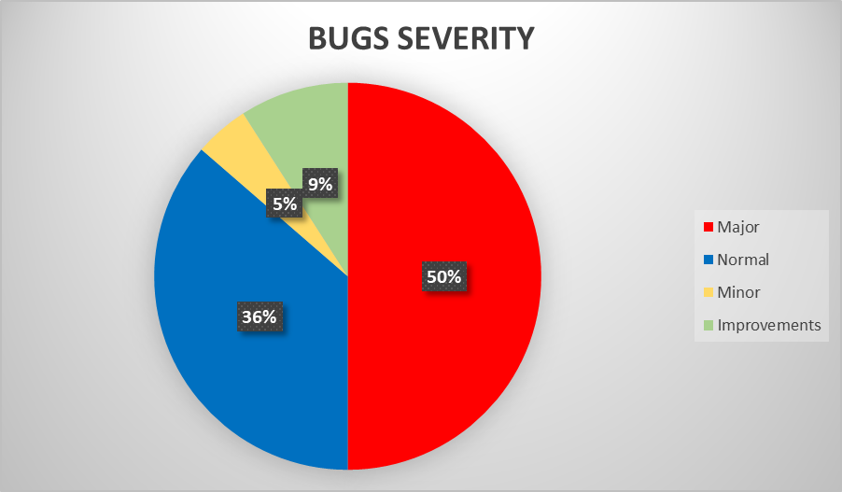

In addition to the Smoke and Exploratory tests performed for the main functionalities, also other types of testing were used: Compatibility testing, Ad-Hoc testing, End-to-end testing, Positive testing and Negative testing.

We tested version 1.0, most tests were performed on the following test environment devices and browsers:



Using different browsers and devices we performed a compatibility test.

Bugs reproduce on all.

Based on the extended Smoke testing performed on the website LYON AUTOSIB SERVICE, reveals several major issues that affect it’s main features and that would result in decreased user retention, therefore the website’s main scope, to bring new clients to the service, will be heavily affected.

In conclusion, all major and normal defects should be checked and closed before release.